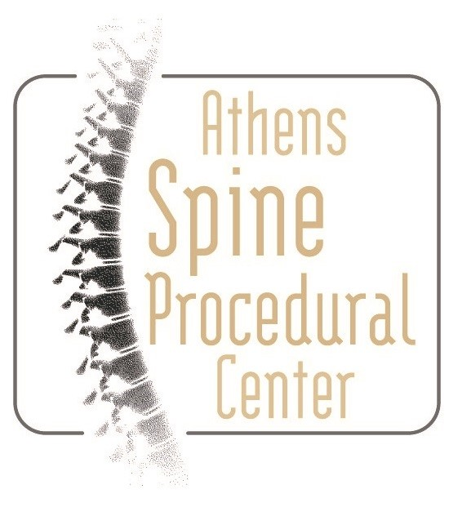
830 King Avenue
Athens, Georgia 30606
(706) 425-2400 Phone
(706) 425-2410 Fax
830 King Avenue
Athens, Georgia 30606
1550 Timothy Road Suite 104
Athens, Georgia 30606
(706) 425-2400 Phone
(706) 425-2410 Fax
1550 Timothy Road Suite 103
Athens, Georgia 30606
(706) 850-5667
(706) 850-6249 Fax
REQUEST TO RESTRICT USE AND DISCLOSURE OF PHI
Patient Name (First, Last) ____________________________________________________________________________
Date of Birth ________________ Email ___________________________________ Phone number ________________
Address __________________________________________________________________________________________
I understand that I have the right to request a restriction on the use and disclosure of my Protected Health Information (PHI) or to revoke a restriction placed on the use or disclosure of my PHI.
This request is: (check one)
❑ New  Modified
❑ TO REVOKE an existing restriction effective (MM/DD/YY) ___________. (Skip to “Restriction to be Revoked” section.)
Restriction Requested
- Restriction on use or disclosure relating to treatment, payment and/or healthcare operations
Please provide details __________________________________________________________________________________________
__________________________________________________________________________________________
__________________________________________________________________________________________
- Restriction on the use and disclosure of PHI: (check all that apply)
  - To a family member, other relative, or other identified person, directly relevant to their involvement with my care or payment for health care services
Please provide details (e.g., restricted information and/or name of family member, friend)
____________________________________________________________________________________
____________________________________________________________________________________
____________________________________________________________________________________
  - Relating to my location, my general condition or my death to a family member, personal representative or other person responsible for my care
Please provide details (e.g., restricted information and/or name of family member, friend)

____________________________________________________________________________________
____________________________________________________________________________________
Restriction to be Revoked
Please provide details: ________________________________________________________________________
__________________________________________________________________________________________
__________________________________________________________________________________________

I understand that:
- Athens Spine Center may not be required to agree to the request.
- I will be provided with a written response to this request and, if denied, the reason for denial.
- If Athens Spine Center does agree, they will comply with my request unless the information is needed to provide me emergency treatment or is required or authorized by law.
- Any restriction accepted will be limited to the information under Athens Spine Center’s control.
- I may revoke this restriction in writing at any time by mailing or delivering the request to Athens Spine Center, 830 King Ave. Athens, GA 30606. The termination will be effective with respect to any PHI created or received after the termination date.

Signed by: ________________________________________________________ Date signed: ___________________
Signature of Patient or Personal Representative

Print Name of Patient or Personal Representative: ______________________________________________________
[If Signed by a Personal Representative, please state such person’s authority to act for the Individual]

FOR ASC USE ONLY
DATE RECEIVED: | REQUEST HAS BEEN:  □ Approved □ Denied
REASON FOR DENIAL:
DATE OF TERMINATION: | REASON FOR TERMINATION:
PATIENT INFORMED BY:
□ Mail □ Telephone □ Email
SIGNATURE/TITLE OF EMPLOYEE PROCESSING: | DATE:

